BUSINESS SECTORS

- ENGINEERING & CONSTRUCTION
- OIL& GAS, PETROCHEMICAL
- POWER & RENEWABLE ENERGY
- WATER & WASTE WATER
- INFRASTRUTURE AND UTILITIES
- OFFSHORE & MARINE
- FACILITIES MANAGEMENT
- OPERATION & MAINTENANCE
- HEALTHCARE & PHARMACEUTICAL
- HOSPITALITY & CATERING
- AUTOMOTIVE, RAIL & AVIATION
- BANKING & INVESTMENT
- PRODUCTION & MANUFACTURING
- FABRICATION & TECHNICAL SERVICES
- WARHOUSING & LOGISTICS

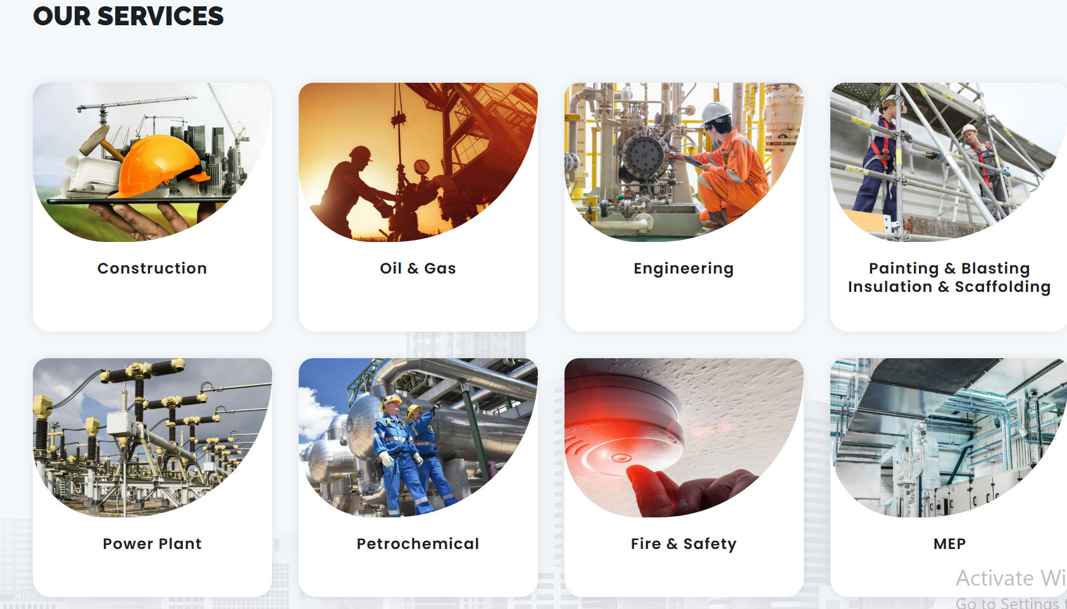

• Engineering & Construction – Build with the best
• Oil & Gas | Petrochemical – Power your projects
• Power & Renewable Energy – Energize innovation
• Water & Wastewater – Sustain critical resources
• Infrastructure & Utilities – Strengthen essential services
• Offshore & Marine – Navigate complex operations
• Facilities Management – Optimize operations
• Operation & Maintenance – Keep systems running
• Healthcare & Pharmaceutical – Deliver excellence in care
• Hospitality & Catering – Enhance service standards
• Automotive, Rail & Aviation – Drive mobility solutions
• Production & Manufacturing – Boost efficiency
• Fabrication & Technical Services – Precision expertise
• Warehousing & Logistics – Streamline supply chains

